

**PROJECT FRONTEND**

**JM SCHOOL (Elearning website)**

***Submitted By***

Zohra Sardar

(20P-0754)

Wajiha Mehboob

(20P-00476)

***Submitted to***

Mr.Musadiq Mansoor

**DEPARTMENT OF COMPUTER SCIENCE**

**FAST NATIONAL UNIVERSITY OF COMPUTER AND EMERGING SCINCES, PESHAWAR**

**FRONTEND INCLUDES FOLLOWING FUNCTIONALITY**

1. Home page
2. Login page
3. Signup
4. Admin
5. Course
6. Payment
7. Feedback(5 star system)

* **HOME PAGE**



Home page consist of following sections

* Header
* Video display
* Banners
* Static courses cards(as its only frontend)
* Contact us form
* 5 star rating
* About us section
* Footer

**HEADER**

**VIDEO DISPLAY**



**BANNERS**





**STATIC COURCES**

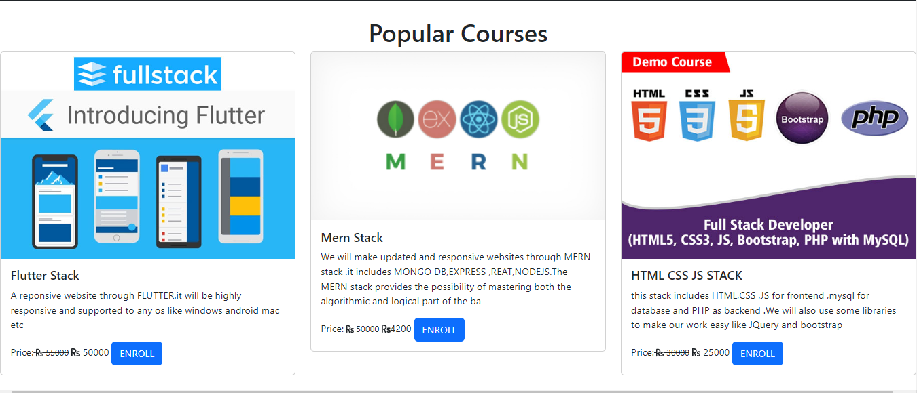

**Contact us form**

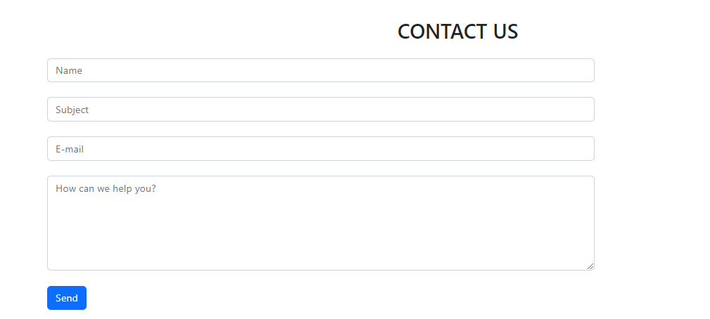

**5 STAR RATING**



**ABOUT US SECTION**

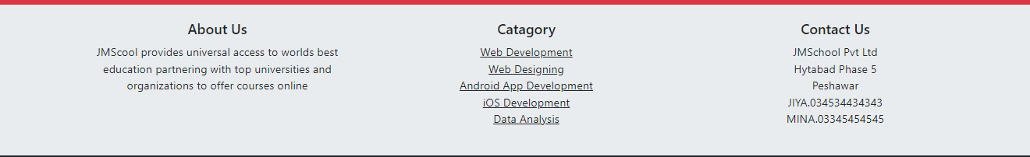

**FOOTER**

We can go to admin page by clicking on admin in footer



**LOGIN PAGE**

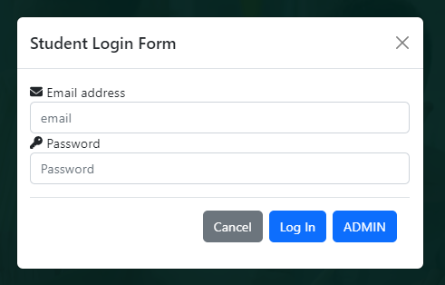

**SIGNUP PAGE**

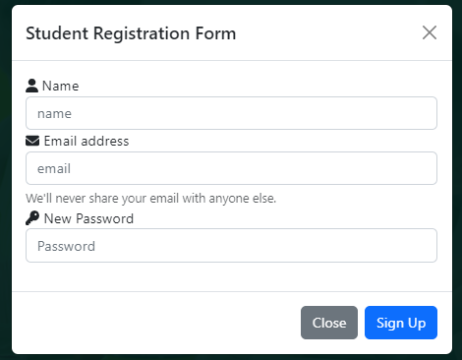

**ADMIN**



**COURSES**





**FEEDBACK**



**NOTE**

We have uploaded only frontend all courses are completely

Static

**EMAIL VARIFICATION USING JAVASCRIPT**

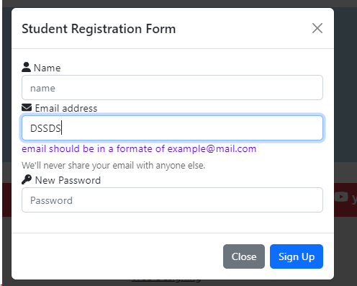

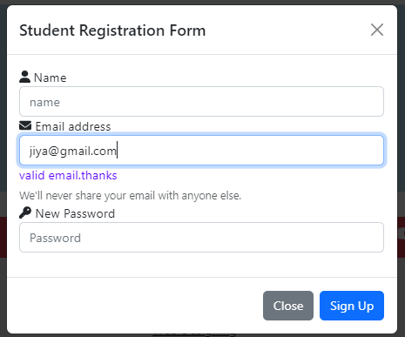

Code is attached in .rar file